Q.1 Initialize a git repository.
Ans. Git init
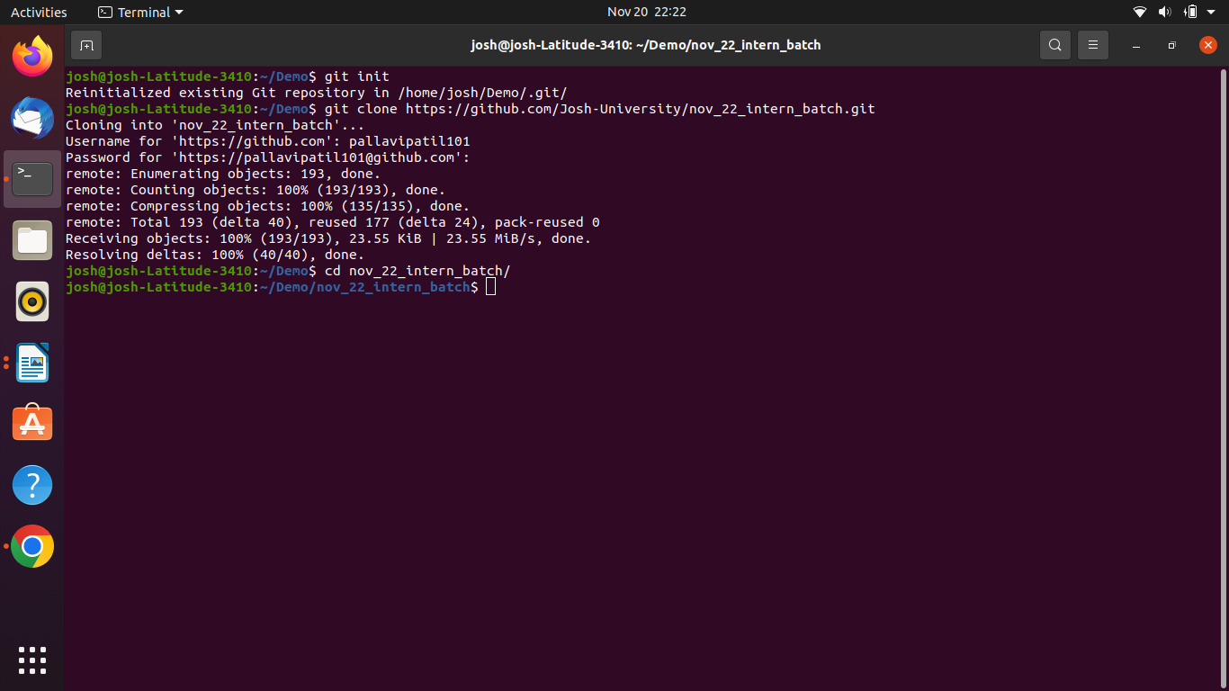

Q.3 ry these commands, stash, reset soft, reset hard, diff, branch -d & -D - push each branch to remote.

-d
git branch -d BranchName
git push -d origin BranchName

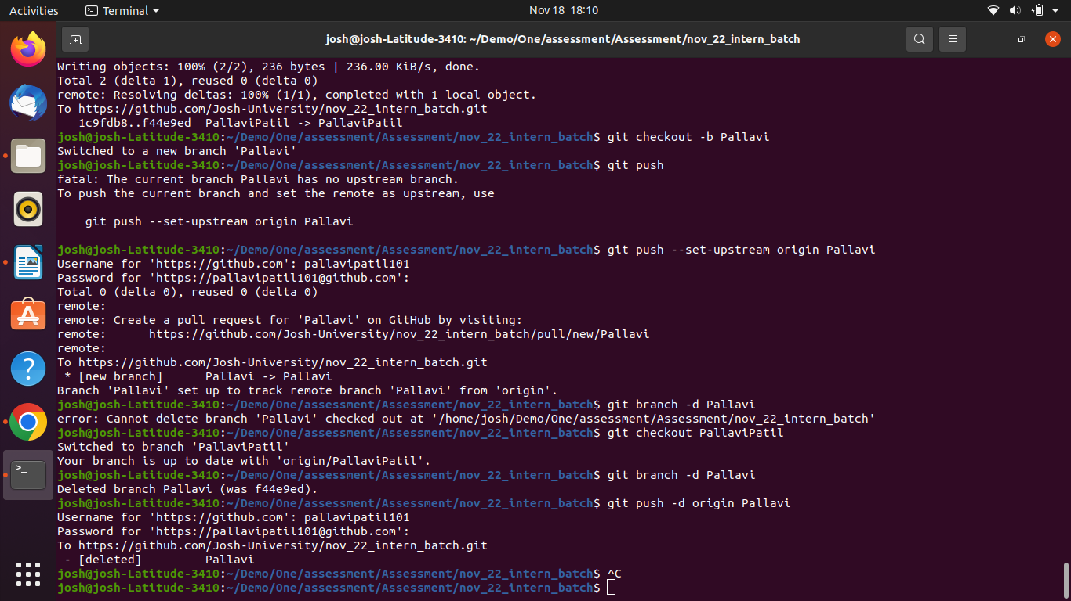

git diff
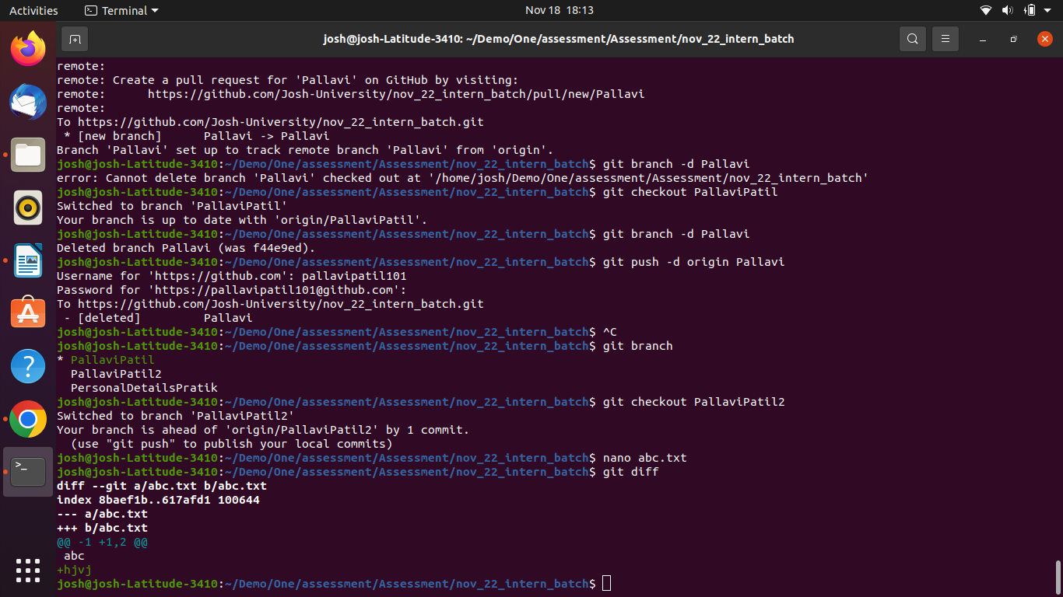

Q.2 Create at least 2 feature branches from main branch (Add multiple files).
Q.3Add commits on each feature branch.

Ans. git checkout -b BranchName
git push –set-upstream origin BranchName
nano File.txt
add .
git commit -m “First file added”
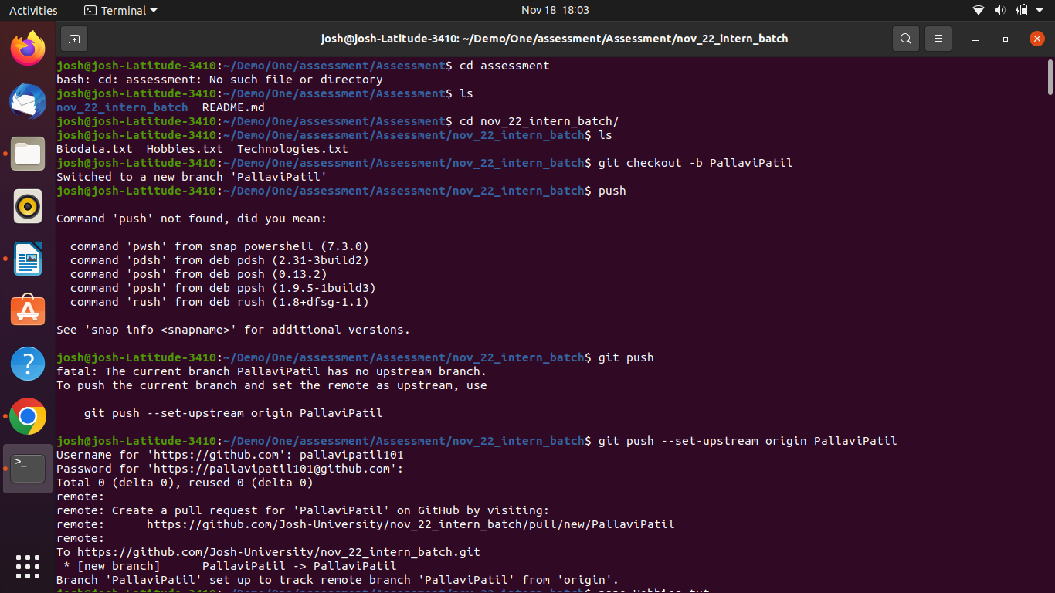
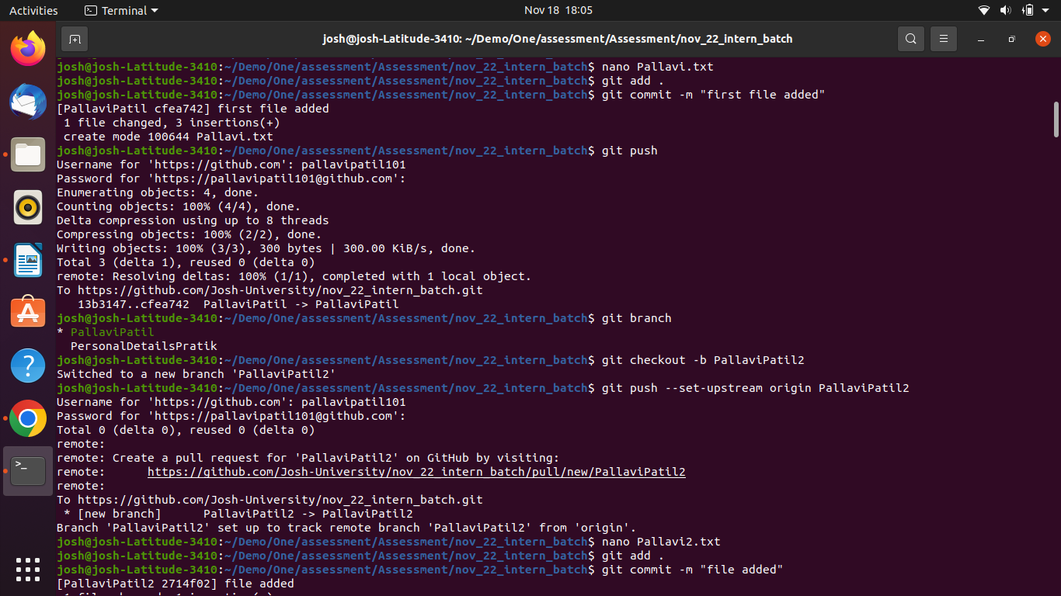
git push

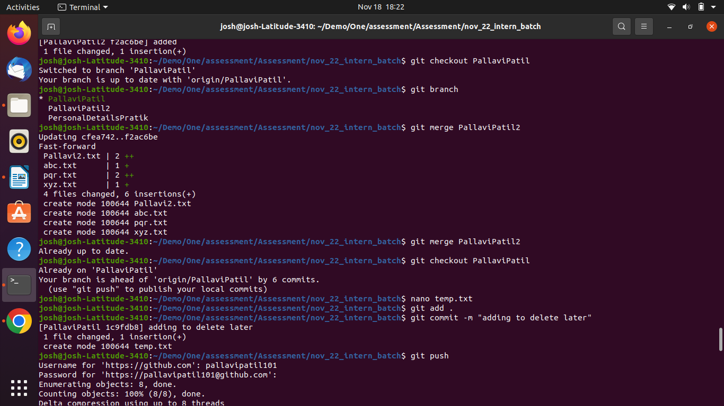
Merge:
git merge branchname

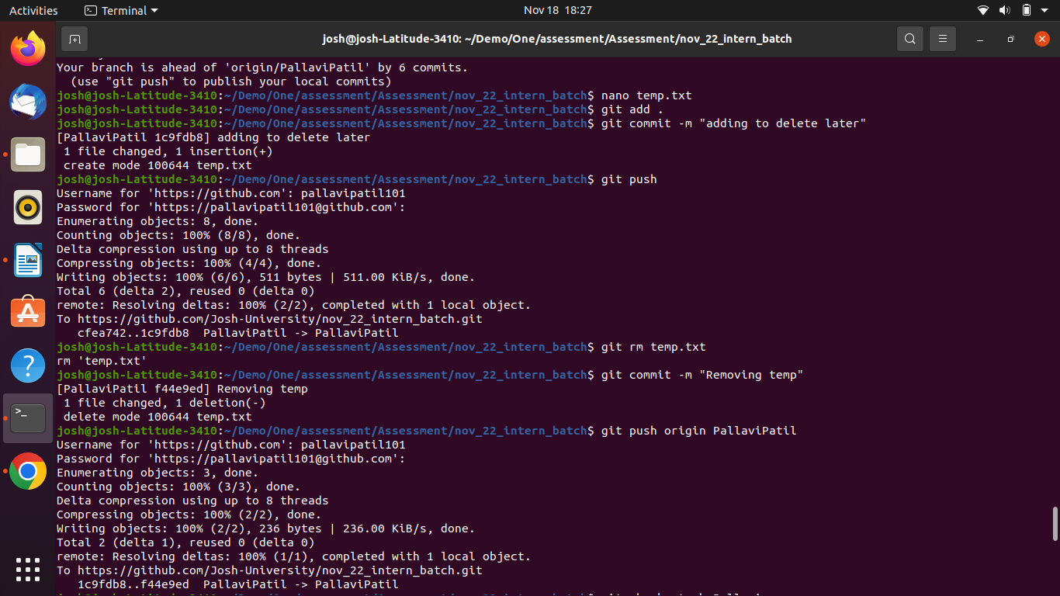
Removing a file:
git rm filename.txt
git commit -m “removing”

Q.4 Try these commands, stash, reset soft, reset hard, diff, branch -d & -D - push each branch to remote.
git reset commit_id

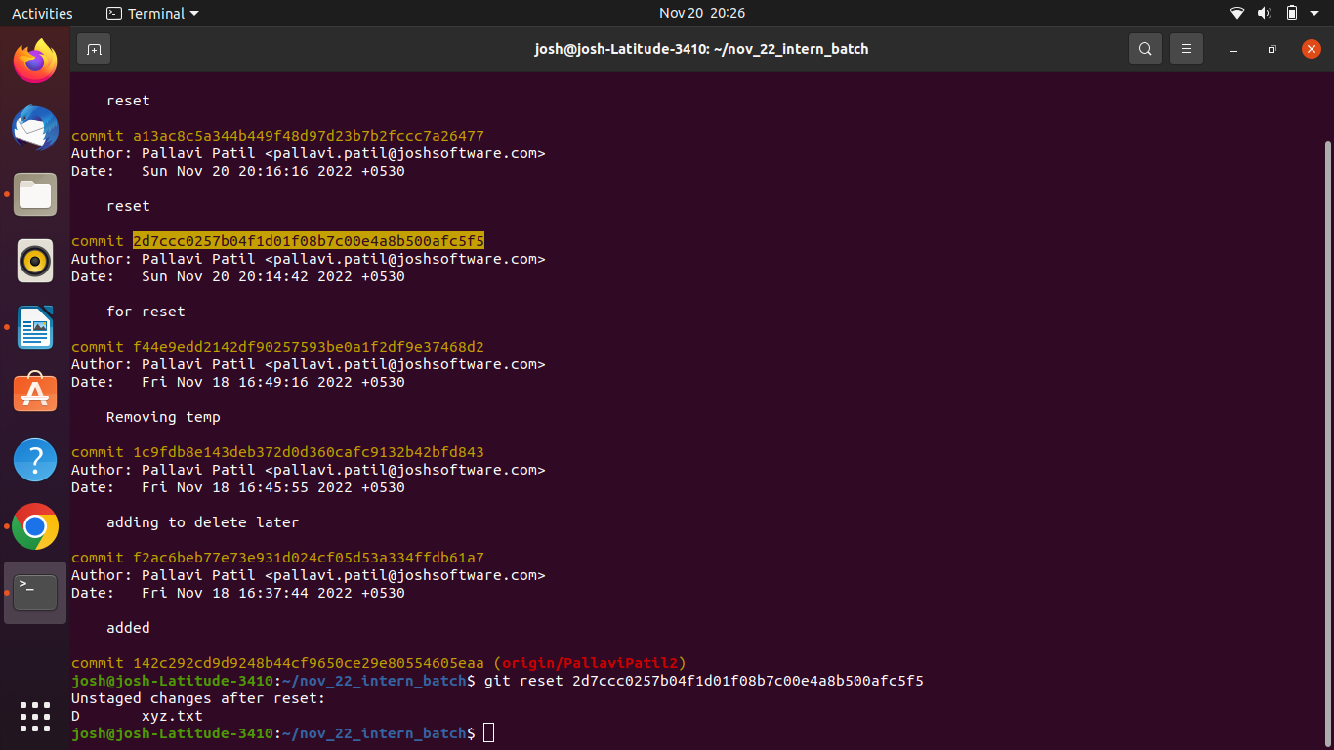
reset hard: git reset --hard
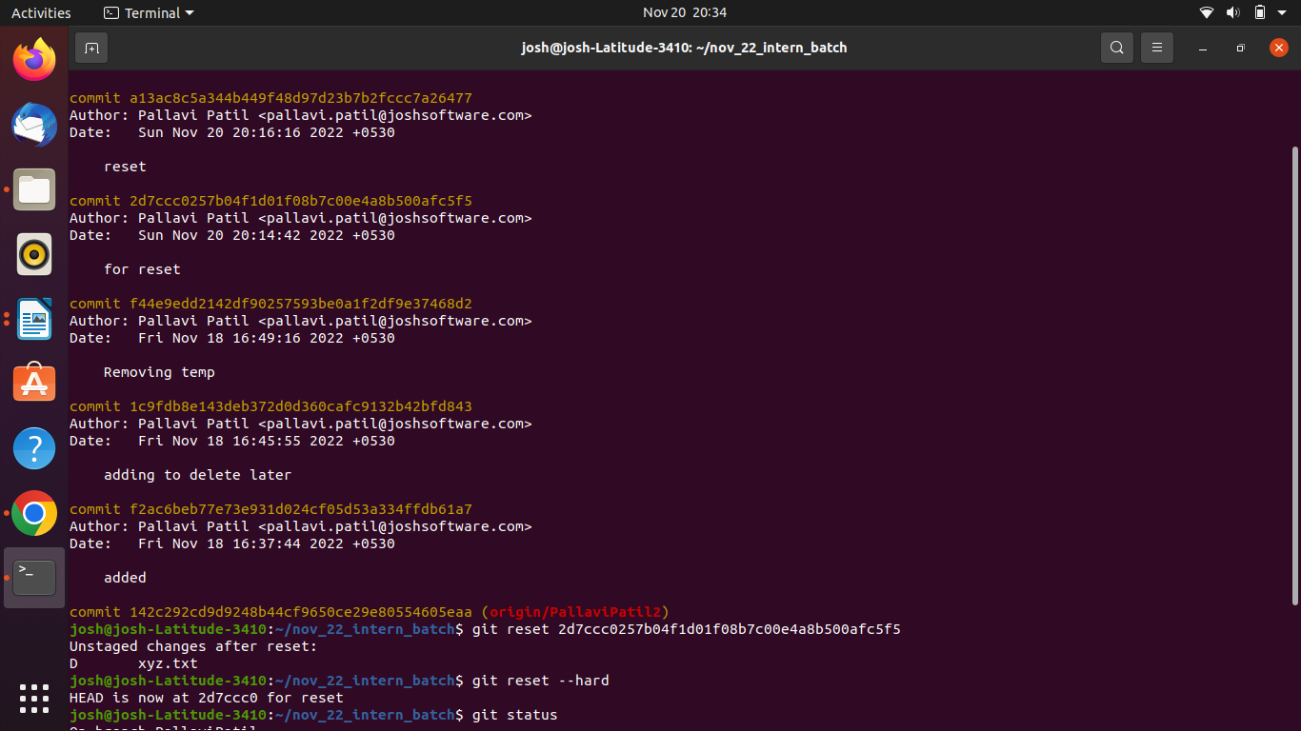

STASH:
git stash save “comment” OR git stash push -m “comment”
git stash apply, git stash pop, git stash drop, git stash clear
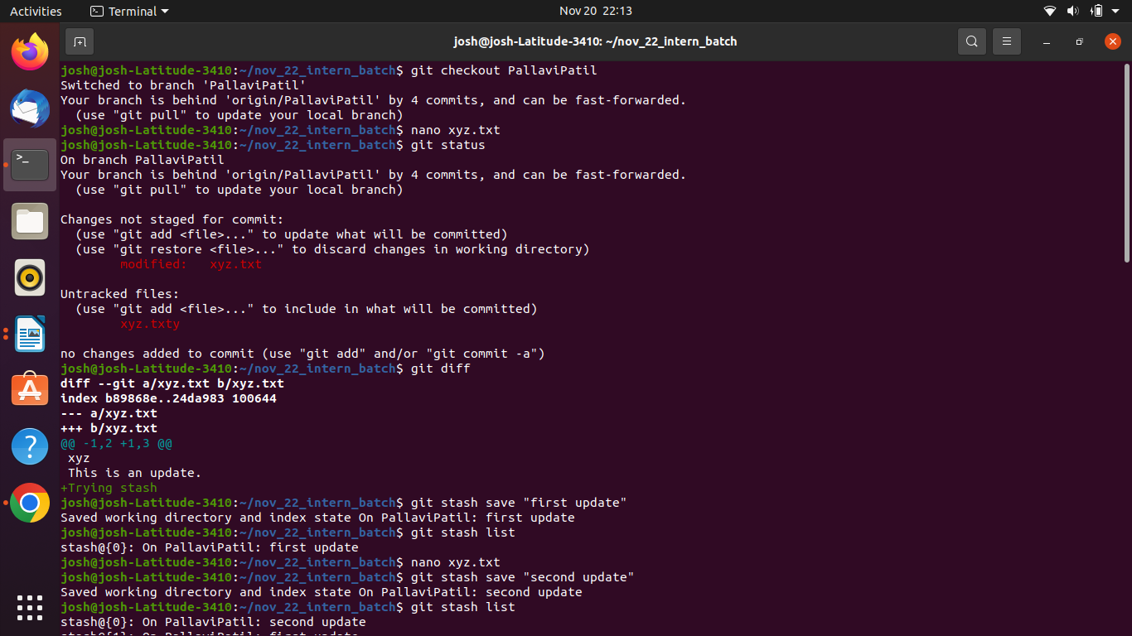

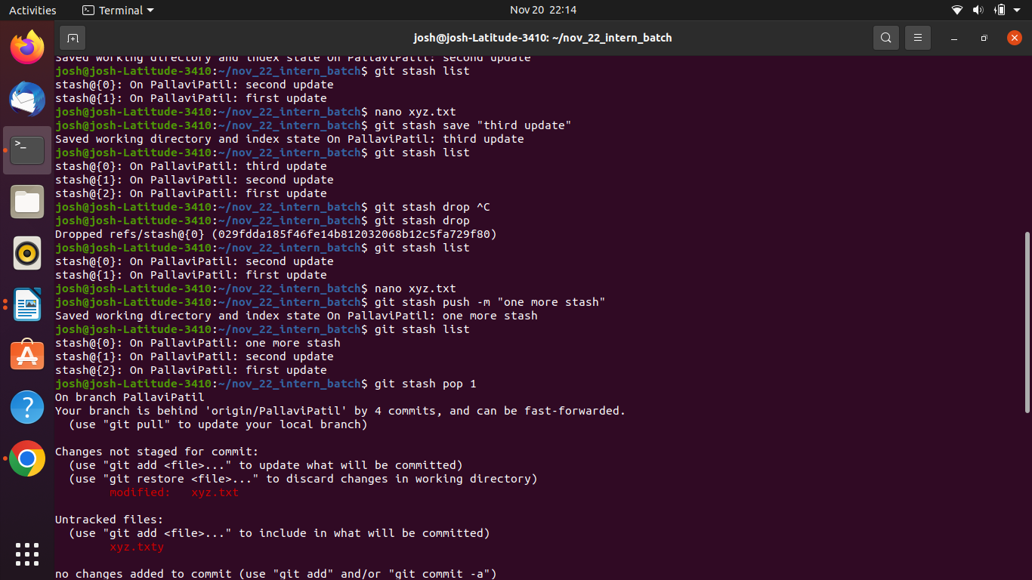

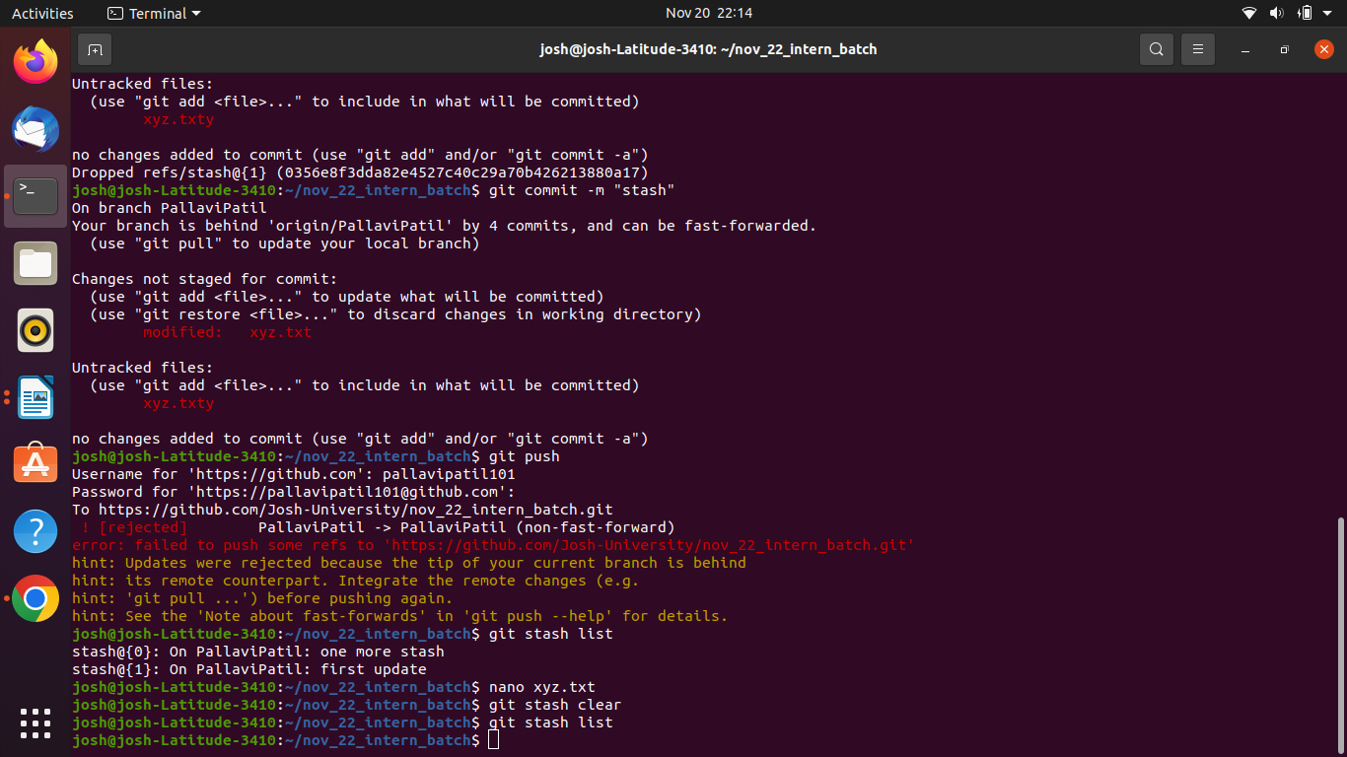

git diff

git -D: git branch -D BranchName
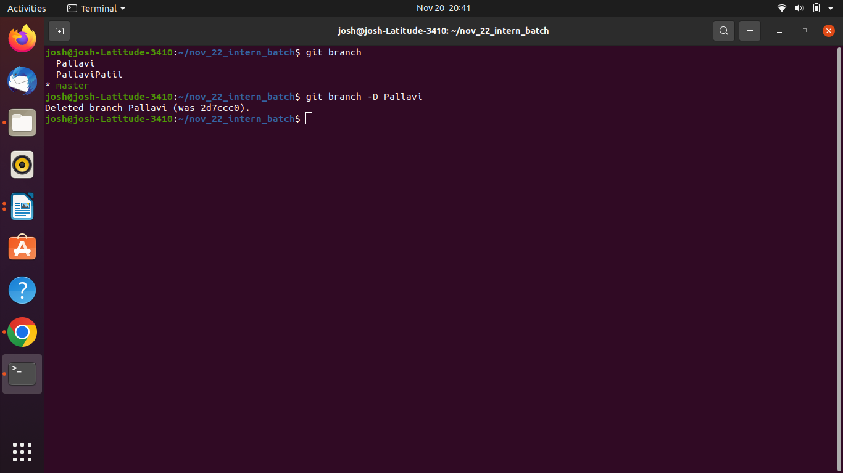

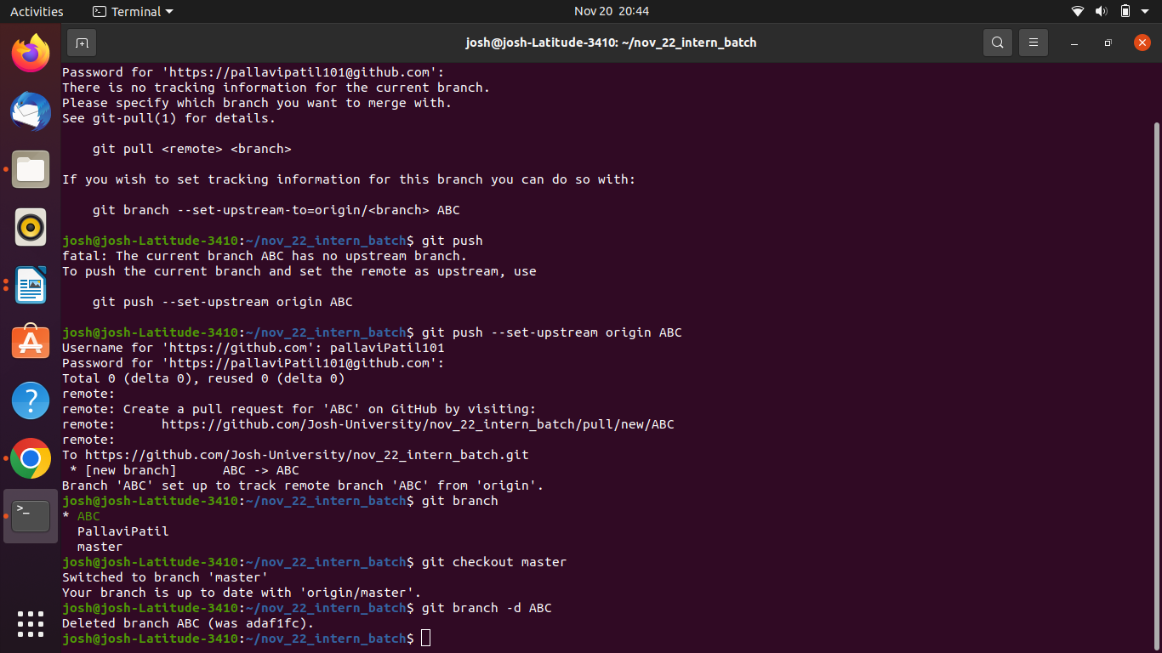
git -d: git branch -d BranchNAme

